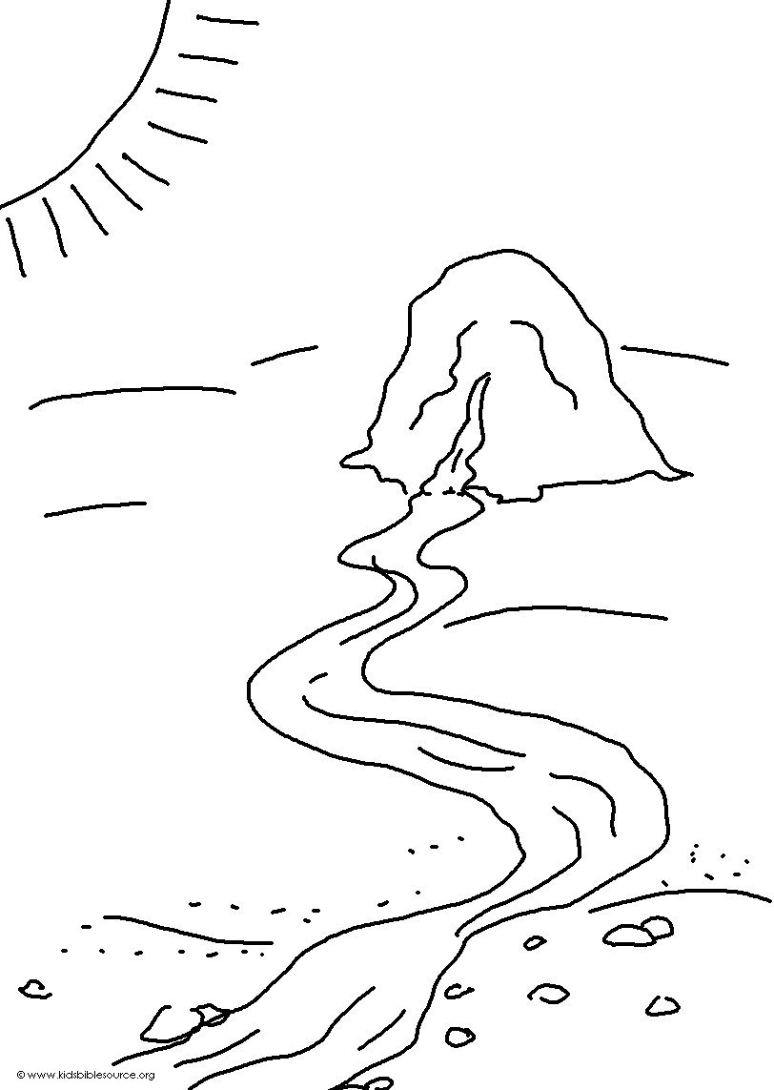
_ _ _ _ will be _ _ _ _ _ _ _ _ to them, and they will have _ _ _ _ _ in abundance.
Isaiah 33:16_{NLT}

